Ingredient Technical Brief
7th Annual Ocean Spray Cranberries, Inc. Student Product Development Competition

Cranberries – Red & Yellow Varietals: | Cranberries prepared from the sound, mature berries of the commonly cultivated cranberry plant (Genus/species - Vaccinium macrocarpon). The product is prepared by grading to assure a wholesome product. No color requirements.  ‘Yellow Bell’ is the only native cranberry variety that is yellow at full maturity. The fruit is small at an average of 1g/berry, usually pyriform, and may have a slight red blush. The flavor is generally cranberry-like but the high skin-to-flesh ratio may give a more astringent/bitter taste and the aromatic notes have been described as floral.  Store at 0-32F until ready to use.  Frozen Cranberry Specifications  Form Frozen Whole Cranberries  Flavor, Aroma & Color Normal odor & flavor, free from off notes; Red varietals are typical cranberry red; uniform, bright distribution of red, pink and white fruit. Yellow varietals are generally yellow, but may have a slight red blush.  Size 98% of the berries must have a diameter of 9/32” min.
Nutritional Analysis Frozen Cranberries
Per 100 g unrounded
Calories | 47.81
Calories from Fat | 0 g
Total Carbohydrates | 10.39 g
Total Sugars | 4.10 g
Added Sugars | 0 g
Dietary Fiber | 4.46 g
Protein | 0.55 g
Total Fat | 0.45 g
Saturated Fat | 0 g
Trans Fat | 0 g
Moisture | 88.21 g
Vitamin A | 0.0 mg
Vitamin C | 18.20 mg
Calcium | 10.0 mg
Magnesium | 6.00 mg
Phosphorus | 10.30 mg
Potassium | 73.0 mg
Sodium | 3.0 mg

Cranberry Seeds: | Cranberry Seeds are obtained from sound, mature berries of the commonly cultivated cranberry plant (Genus/species - Vaccinium macrocarpon). Cranberry seeds are prepared by the mechanical separation of the wholesome cranberry pulp and then dried to a specific moisture. No additives, preservatives or other processing aids are added.  Stored Ambient.  Cranberry Seeds Specifications  % Moisture < 7.0  Water Activity < 0.60  Particle Size ≤ 12 mesh  Appearance, Aroma, & Flavor Characteristic deep red cranberry color; mild cranberry flavor & clean fruity aroma with no off-flavors or odors  Nutritional Analysis Cranberry Seeds  Per 100 g  Calories 212.66  Calories from Fat 104.76  Total Carbohydrates 58.90 g  Available Carbohydrates 3.03 g  Total Sugars 2.28 g  Added Sugars 0 g  Total Dietary Fiber 55.87 g  Soluble Fiber 4.56 g  Insoluble Fiber 51.30 g  Protein 21.66 g  Total Fat 11.64 g  Polyunsaturated Fat 17.71 g  Monounsaturated Fat 2.61 g  Saturated Fat 0.82 g  Trans Fat 0.0 g  Moisture 5.56 g  Ash 2.24 g  Vitamin E 2.02 mg  Calcium 179.25 mg  Magnesium 185.67 mg  Potassium 495.67 mg  Sodium 4.19 mg
Cranberry Juice Concentrate: | Cranberry juice concentrate is viscous red liquid prepared from the extracted, depectinized and filtered juice of sound, clean cranberries (Vaccinium macrocarpon).  Storage:  Short Term: 35°F ± 5°F up to 30 days from date produced.  Long term: Freeze at 0°F ± 10°F  To thaw: place in cool water bath for 30min-1hr and shake vigorously before  using.  Cranberry Juice Conc. Specifications  ⁰Brix (@ 20⁰C) 50 +/- 0.05  Titratable Acidity (% w/w as citric) Minimum 12.5  Appearance & Aroma (as a concentrate) Clear; dark red color; cranberry aroma; sweet and sour taste with strong astringency.  Appearance, Aroma, & Flavor (as Beverage) Clear; dark red to bright red color; cranberry aroma; sweet and sour taste with moderate astringency.  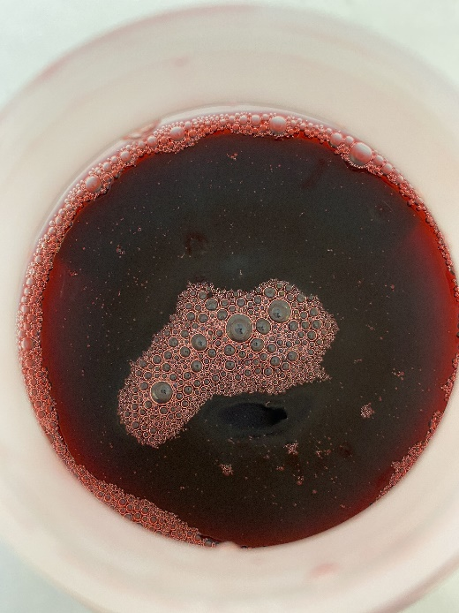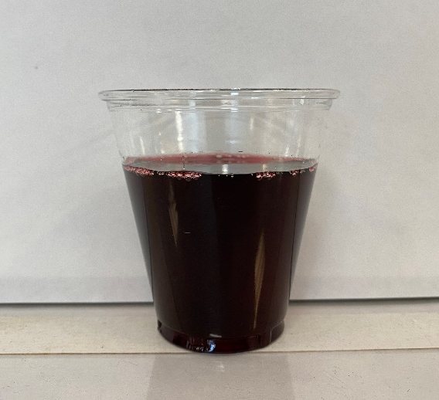  Nutritional Analysis Cranberry Juice Concentrate Type-C  Per 100 g- unrounded  Calories 206  Calories from Fat 0  Total Carbohydrates 51.3 g  Total Sugars 26.6 g  Added Sugars 0 g  Dietary Fiber 0.5 g  Protein 0.20 g  Total Fat 0 g  Saturated Fat 0 g  Trans Fat 0 g  Cholesterol 0 mg  Moisture 47.5 g  Ash 1.0 g  Vitamin C 0 mg  Calcium 34.2 mg  Iron 0.50 mg  Magnesium 28.0 mg  Phosphorus 24.7 mg  Potassium 463 mg  Sodium 18.2 mg

