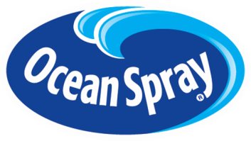
The 7th Annual Ocean Spray Cranberries, Inc.
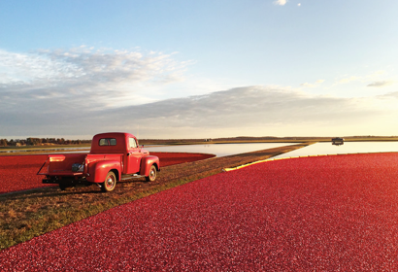
Student Product Development Competition
The objective of this competition is to develop two unique and versatile sauces, condiments or dips aimed at elevating the home cooking experience while utilizing cranberries.
Theme: | Elevate the at-home culinary experience through the power of Ocean Spray® Cranberries
The Challenge: | Given the pandemic’s safety measures, more people are looking to diversify their home cooking by introducing exciting new flavors to their kitchen. The challenge this year is to develop two (2) unique and versatile sauces, condiments or dips that feature cranberries and will inspire home cooks to use cranberry outside of the holiday season.  The participants are challenged with developing a product in their kitchens, using ONLY common kitchen equipment/appliances. The developed product should aim at food flavor elevation. The participants will develop two variants of the product: one utilizing Yellow Bell cranberries (yellow in color) and the other utilizing the common Stevens variety (red in color). At least one the variant must be inspired by international flavors! Entries will be evaluated based on product originality, cranberry content, technical feasibility and marketability of the product.
The Trend: | Seventy-five percent of consumers think of cranberry sauce as a Thanksgiving staple. How do we harness that consumer trust and convert it into an everyday product? The condiment and sauce category is huge at approximately $70 Billion annually and growing. Given the Covid-19 shift, driving consumers to cook more at home, how do we develop a product that helps elevate consumers eating experiences?
Target Audience: | Your product should target a diverse group of aspiring home cooks of all ages.

